Sitecore Video Field

User Manual

Content

Introduction 2

References 2

Installation 2

About HTML 5 video element 2

Using the video field 3

Rendering 5

Known issues 5

# Introduction

This document describes how you can use the Sitecore Video Field. It describes in detail what steps to follow to install and use the module. It is intended for use by editors.

# References

1. The GitHub repository where this project is being maintained:  
   <https://github.com/WeLoveSitecore/SitecoreVideoField>
2. This project was WLS’s entry for this Hackathon:  
   <http://sitecorehackathon.org/sitecore-hackathon-2016/>

# Installation

1. Download the most recent installable ZIP package from this page:  
   <https://github.com/WeLoveSitecore/SitecoreVideoField/tree/master/Package>
2. Login to Sitecore using the Sitecore Desktop.
3. Open the Installation Wizard.
4. Upload the package and install it (if you get any messages about conflicts, choose “Merge” and then “Merge” again).
5. You’re all set to start using the Video Field!

# About HTML 5 video element

It’s an element introduced to render videos in a web page and to replace the existing plugins used for rendering videos.

<video poster="/sitecore/shell/-/media/Habitat/Images/Content/Anders-Laub-Christoffersen.jpg" width="500" height="400" controls autoplay >

< source src ="http://www.sample-videos.com/video/mp4/720/big_buck_bunny_720p_1mb.mp4" type="video/mp4"/>

< source src ="http://www.sample-videos.com/video/mp4/720/big_buck_bunny_720p_1mb.mp4" type="video/mp4"/>

Your browser does not support the video tag.

</video>

The controls attribute adds video controls, like play, pause, and volume.

It is a good idea to always include width and height attributes.

If height and width are not set, the browser does not know the size of the video. The effect will be that the page will change (or flicker) while the video loads.

Other attributes are autoplay, loop, muted and preload.

Text between the <video> and </video> tags will only display in browsers that do not support the <video> element.

Multiple <source> elements can link to different video files. The browser will use the first recognized format.

**HTML Video - Browser Support**

Currently, there are 3 supported video formats for the <video> element: MP4, WebM, and Ogg:

|  |  |  |  |
| --- | --- | --- | --- |
| Browser | MP4 | WebM | Ogg |
| Internet Explorer | YES | NO | NO |
| Chrome | YES | YES | YES |
| Firefox | YES | YES | YES |
| Safari | YES | NO | NO |
| Opera | YES (from Opera 25) | YES | YES |

# Using the video field

If you go to any item template, you will find a video field type under link types category:

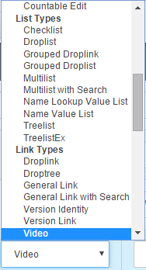

Now go to an item that contains a video field. You will find a field that looks like the picture below:

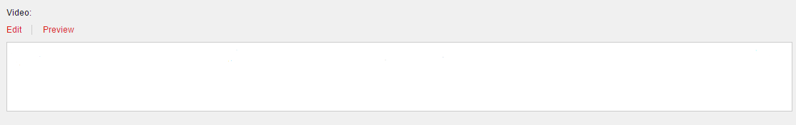

If you choose edit a dialog form will open and you can introduce some information about the video:

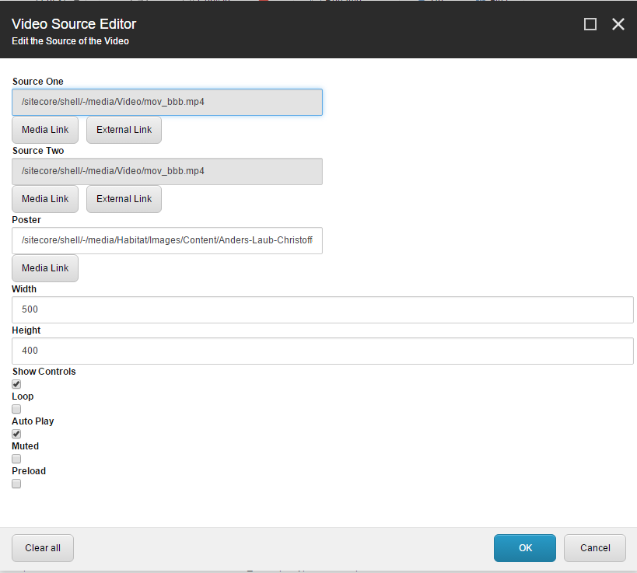

As I said in the introduction, our model is based on the HTML 5 video tag, and here you will be able to set the attributes for rendering the video.

We used 2 sources to have a fallback in case one of the formats is not supported by a browser (see the table with the supported formats).

Media Link will take you to the media folder in Sitecore, where you can select an existing video or upload a new one.

Accessing external link, you can introduce add a video that is not uploaded in Sitecore. The link cannot be a YouTube or Vimeo video. The format should respect this model:

<http://www.sample-videos.com/video/mp4/720/big_buck_bunny_720p_1mb.mp4>

For a poster you can select any image available in the media folder.

We recommend setting a size, otherwise the video might not show.

The rest of the attributes are optional, but consider that you will cannot play the video if there are no controls.

# Rendering

For rendering we created a HTML Helper that has 2 parameters: field name and an item.

@Html.Sitecore().VideoField("Video", currentItem)

Create a View Rendering using this path: /ViewsVideo/VideoDemo.cshtml. As a placeholder you can use anything.

# Known issues

Until the submission of the module the following issues have been registered and marked as known issues.

* The field can’t be edited in Experience Editor.